

**Project Report**

**On**

**Airline Ticket Reservation System**

(CSD 2206-5 DATABASE DESIGN AND SQL)

**Submitted to: Submitted by:**

Ms. Rachida Amjoun Lovepreet Kaur (C0763499)

Minh Phuong Ly (C0757038)

Aneesha Ann Aloysious (C0769743)

Honey Mathew (C0765178)

**CONTENTS**

INTRODUCTION 3

REQUIREMENT ANALYSIS 4

Overview: 4

Entity, Attribute and Relationship Identification 5

**Entities and Attributes:** 5

**Relationships:** 5

CONCEPTUAL MODEL (E-R DIAGRAM) 6

LOGICAL DESIGN 8

**Relational schemas:** 8

**Third Normalization Form:** 8

Physical Table Representation 9

# INTRODUCTION

Airline Ticket Reservation System is a database project that facilitate the reservation of the online air tickets through an effective and yet simple GUI for a normal passenger intending to travel in airways. The project is basically targeted all those people who would like to travel through air. Apart from reserving tickets, through this system a passenger can compare fares ‘from’ various cities ‘to’ various cities.

# REQUIREMENT ANALYSIS

## Overview:

The Airline Ticket Reservation System should fulfill the following requirements:

* Keeping records of different flights of a particular airline at various places.
* Keeping the records of a specific passengers like passport number, address and contact number etc.
* Keep record of total hours of a specific aircraft has served during a specific time interval.
* Provides details related to number of aircrafts belonging to a specific airline.
* The system will keep record of the total number of hours that a specific passenger has travelled during a specific time interval.
* The system will give information about the total number of hours that a specific airline has been running during a specific time interval.
* It provides list of all passengers who flew to a specific city during a specific time interval.
* Point out the most visited city during the last month.
* Generating a list of aircrafts that have not been in used from a specific source location.
* It creates list of airlines that run flight from a specific source to a destination.
* It provides the list of all options that a passenger can have when travelling from a source to a destination. This includes a connecting flight, for instance, a passenger is travelling from Toronto to Delhi and there is no direct flight, therefore, you have to find the options for this passenger.
* It provides the detailed description of minimum hours that it will take for a passenger to travel from a source city to a destination city. Again, consider the connecting flights as mentioned in item number 9, e.g. travelling from Toronto to Delhi.

# Entity, Attribute and Relationship Identification

## **Entities and Attributes:**

1. TICKET has attributes: ticket_id (primary key), booking_id (foreign key), passenger_id(foreign key), flight_id(foreign key), class, seat_number, status, issued_date
2. FLIGHT stores all information of all flights and it has attributes: flight_id(primary key), aircraft_id(foreign key), depart_date, eco_class_price, bus_class_price, arrival_date, gate_id(foreign key), route_id(foreign key), status
3. AIRLINE has attributes: airline_id(primary key), airline_name, description
4. AIRCRAFT has attributes: aircraft_id(primary key), airline_id (foreign key), aircraft_name, number_eco_seat, number_bus_seat, description
5. PASSENGER has attributes: passenger_id(primary key), passport_number(foreign key)
6. PASSENGER_INFO has attributes: passport_number(primary key), name, phone, date_of_birth, address, email
7. TERMINAL has attributes: terminal_id(primary key), airport_id(foreign key), terminal_name, description
8. GATE has attributes: gate_id(primary key), terminal_id(foreign key), gate_name
9. AIRPORT has attributes: airport_id(primary key), name, country, city, description
10. PAYMENT_ACCOUNT has attributes: card_id(primary key), name, password, expire_date
11. BOOKING has attributes: booking_id(primary_key), card_id(foreign key), status, discount, issued_date
12. ROUTE entity provides details about direct route from one source to a destination. It has attributes: route_id(primary key), source_airport_id(foreign key), destination_airport_id(foreign key)
13. ROUTE_GROUP entity is especially for getting information about connecting flights from one destination to other. It has attributes: route_group_id(primary key), source_airport_id(foreign key), destination_airport_id(foreign key)

## **Relationships:**

1. ROUTE_GROUP_DETAIL plays a role of solving many to many relationship problem between ROUTE and ROUTE_GROUP entities. It has attributes: route_group_id ( primary key, foreign key), route_id (primary key, foreign key)

# CONCEPTUAL MODEL (E-R DIAGRAM)

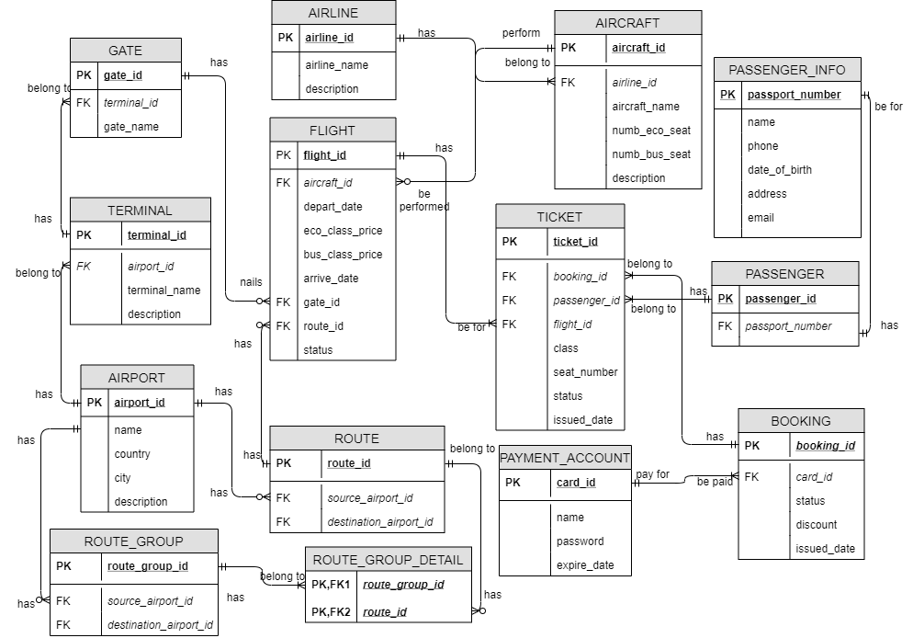

The ER diagram fulfils the following user requirements:

* The airline ticket reservation system can keep track of different flights of a particular airline at various places.
* Also, this system can keep the records of a specific passengers like passport number, address and contact number etc.
* The system can keep record of total hours of a specific aircraft has served during a specific time interval
* This can provide details related to number of aircrafts belonging to a specific airline
* The system can keep record of the total number of hours that a specific passenger has travelled during a specific time interval
* The system can give information about the total number of hours that a specific airline has been running during a specific time interval
* It provides list of all passengers who flew to a specific city during a specific time interval
* This ERD point out the most visited city during the last month
* It can generate a list of aircrafts that have **not** been in used from a specific source location
* It can create list of airlines that run flight from a specific source to a destination
* This airline system can provide the list of all options that a passenger can have when travelling from a source to a destination. This includes a connecting flight, for instance, a passenger is travelling from Toronto to Delhi and there is no direct flight, therefore, you have to find the options for this passenger
* This ERD results the detailed description of minimum hours that it will take for a passenger to travel from a source city to a destination city. Again, consider the connecting flights as mentioned in item number 9, e.g. travelling from Toronto to Delhi.

# LOGICAL DESIGN

**Relational schemas:**

TICKET (**ticket_id**, *booking_id, passenger_id, flight_id,* class, seat_number, status, issued_date)

PASSENGER (**passenger_id**, *passport_number*)

PASSENGER_INFO (**passport_number**, name, phone, date_of_birth, address, email)

GATE (**gate_id**, *terminal_id*, gate_name)

TERMINAL (**terminal_id**, *airport_id*, terminal_name, description)

BOOKING (**booking_id**, *card_id,* status, discount, issued_date)

PAYMENT_ACCOUNT (**card_id**, name, password, expire_date)

FLIGHT (**flight_id,** *aircraft_id,* depart_date, eco_class_price, bus_class_price, arrive_date, *route_id*, *gate_id*, status)

AIRLINE (**airline id,** airline_name, description)

AIRCRAFT (**aircraft_id,** *airline_id,* aircraft_name, numb_eco_seat, numb_bus_seat, description)

ROUTE (**route id,** *source_airport_id, destination_airport_id*)

ROUTE_GROUP (**route group id,** *source_airport_id, destination_airport_id*)

ROUTE_GROUP_DETAIL (***route group id***, ***route id***)

AIRPORT (**airport id**, name, country, city, description)

## **Third Normalization Form:**

The ERD is already in third normalization form.

# Physical Table Representation

|  |  |  |  |  |
| --- | --- | --- | --- | --- |
| **TERMINAL** | | | | |
| **Column Description** | **Optionality** | **Data Type** | **Size, Digits** | **SQL short name** |
| Terminal ID (PK) | NOT NULL | SMALLINT | 2 | terminal_id |
| IATA Airport ID (FK) | NOT NULL | CHAR | 3 | airport_id |
| Terminal name | NOT NULL | CHAR | 3 | terminal_name |
| Description | NULL | VARCHAR | 10 | description |

|  |  |  |  |  |
| --- | --- | --- | --- | --- |
| **GATE** | | | | |
| **Column Description** | **Optionality** | **Data Type** | **Size, Digits** | **SQL short name** |
| Gate ID (PK) | NOT NULL | SMALLINT | 2 | gate_id |
| Terminal ID (FK) | NOT NULL | SMALLINT | 2 | terminal_id |
| Name of the gate | NOT NULL | VARCHAR | 10 | gate_name |

|  |  |  |  |  |
| --- | --- | --- | --- | --- |
| **AIRPORT** | | | | |
| **Column Description** | **Optionality** | **Data Type** | **Size, Digits** | **SQL short name** |
| IATA Airport ID (PK) | NOT NULL | CHAR | 3 | airport_id |
| Name of airport | NOT NULL | VARCHAR | 50 | name |
| Country | NOT NULL | VARCHAR | 20 | country |
| City | NOT NULL | VARCHAR | 20 | city |
| Description | NULL | VARCHAR | 10 | description |

|  |  |  |  |  |
| --- | --- | --- | --- | --- |
| **AIRLINE** | | | | |
| **Column Description** | **Optionality** | **Data Type** | **Size, Digits** | **SQL short name** |
| IATA ID of Airline (PK) | NOT NULL | CHAR | 2 | airline_id |
| Airline name | NOT NULL | VARCHAR | 50 | airline_name |
| Description | NULL | VARCHAR | 50 | description |

|  |  |  |  |  |
| --- | --- | --- | --- | --- |
| **AIRCRAFT** | | | | |
| **Column Description** | **Optionality** | **Data Type** | **Size, Digits** | **SQL short name** |
| Aircraft ID (PK) | NOT NULL | VARCHAR | 10 | aircraft_id |
| IATA ID of Airline (FK) | NOT NULL | CHAR | 2 | airline_id |
| Aircraft name | NOT NULL | VARCHAR | 50 | aircraft_name |
| Number of eco class seat | NOT NULL | SMALLINT | 3 | number_eco_seat |
| Number of business class seat | NOT NULL | SMALLINT | 3 | number_bus_seat |
| Description | NULL | VARCHAR | 50 | description |

|  |  |  |  |  |
| --- | --- | --- | --- | --- |
| **FLIGHT** | | | | |
| **Column Description** | **Optionality** | **Data Type** | **Size, Digits** | **SQL short name** |
| Flight ID (PK) | NOT NULL | VARCHAR | 10 | flight_id |
| Aircraft ID (FK) | NOT NULL | VARCHAR | 10 | aircraft_id |
| Route ID (FK) | NOT NULL | VARCHAR | 10 | route_id |
| Gate ID (FK) | NOT NULL | SMALLINT | 2 | gate_id |
| Departure date and time | NOT NULL | DATETIME |  | depart_date |
| Arrival date and time | NOT NULL | DATETIME |  | arrive_date |
| Price for economic class | NOT NULL | FLOAT | 15 | eco_class_price |
| Price for business class | NOT NULL | FLOAT | 15 | bus_class_price |
| Status of the flight | NOT NULL | VARCHAR | 10 | status |

|  |  |  |  |  |
| --- | --- | --- | --- | --- |
| **ROUTE** | | | | |
| **Column Description** | **Optionality** | **Data Type** | **Size, Digits** | **SQL short name** |
| Route ID (PK) | NOT NULL | VARCHAR | 10 | route_id |
| IATA source Airport ID (FK) | NOT NULL | CHAR | 3 | source_airport_id |
| IATA destination Airport ID (FK) | NOT NULL | CHAR | 3 | destination_airport_id |

|  |  |  |  |  |
| --- | --- | --- | --- | --- |
| **ROUTE_GROUP_DETAIL** | | | | |
| **Column Description** | **Optionality** | **Data Type** | **Size, Digits** | **SQL short name** |
| Route ID (PK,FK) | NOT NULL | VARCHAR | 10 | route_id |
| Route group ID (PK,FK) | NOT NULL | VARCHAR | 10 | route_group_id |

|  |  |  |  |  |
| --- | --- | --- | --- | --- |
| **ROUTE_GROUP** | | | | |
| **Column Description** | **Optionality** | **Data Type** | **Size, Digits** | **SQL short name** |
| Route group ID (PK) | NOT NULL | VARCHAR | 10 | route_group_id |
| IATA source Airport ID (FK) | NOT NULL | CHAR | 3 | source_airport_id |
| IATA destination Airport ID (FK) | NOT NULL | CHAR | 3 | destination_airport_id |

|  |  |  |  |  |
| --- | --- | --- | --- | --- |
| **TICKET** | | | | |
| **Column Description** | **Optionality** | **Data Type** | **Size, Digits** | **SQL short name** |
| Ticket ID (PK) | NOT NULL | VARCHAR | 20 | ticket_id |
| Booking ID (FK) | NOT NULL | VARCHAR | 20 | booking_id |
| Passenger ID (FK) | NOT NULL | VARCHAR | 20 | passenger_id |
| Flight ID (FK) | NOT NULL | VARCHAR | 10 | flight_id |
| Class of the ticket | NOT NULL | VARCHAR | 5 | class |
| The seat number | NULL | VARCHAR | 3 | seat_number |
| Status of the ticket | NOT NULL | VARCHAR | 10 | status |
| Issued date and time | NOT NULL | DATETIME |  | issued_date |

|  |  |  |  |  |
| --- | --- | --- | --- | --- |
| **PASSENGER** | | | | |
| **Column Description** | **Optionality** | **Data Type** | **Size, Digits** | **SQL short name** |
| Passenger ID (PK) | NOT NULL | VARCHAR | 20 | passenger_id |
| Passort number(FK) | NOT NULL | VARCHAR | 20 | passport_number |

|  |  |  |  |  |
| --- | --- | --- | --- | --- |
| **PASSENGER_INFO** | | | | |
| **Column Description** | **Optionality** | **Data Type** | **Size, Digits** | **SQL short name** |
| Passort number (PK) | NOT NULL | VARCHAR | 20 | passport_number |
| Passenger name | NOT NULL | VARCHAR | 30 | name |
| Contact phone number | NOT NULL | CHAR | 10 | phone |
| Date of birth | NOT NULL | DATE |  | date_of_birth |
| Address | NOT NULL | VARCHAR | 50 | address |
| Contact email | NOT NULL | VARCHAR | 30 | email |

|  |  |  |  |  |
| --- | --- | --- | --- | --- |
| **BOOKING** | | | | |
| **Column Description** | **Optionality** | **Data Type** | **Size, Digits** | **SQL short name** |
| Booking ID (PK) | NOT NULL | VARCHAR | 20 | booking_id |
| Card ID (FK) | NOT NULL | VARCHAR | 20 | card_id |
| Status of booking | NULL | VARCHAR | 10 | status |
| Discount | NOT NULL | FLOAT | 4 | discount |
| Booking issued date and time | NOT NULL | DATETIME |  | issued_date |

|  |  |  |  |  |
| --- | --- | --- | --- | --- |
| **PAYMENT_ACCOUNT** | | | | |
| **Column Description** | **Optionality** | **Data Type** | **Size, Digits** | **SQL short name** |
| Card ID (PK) | NOT NULL | VARCHAR | 20 | card_id |
| Name on the card | NOT NULL | VARCHAR | 30 | name |
| Password | NOT NULL | SMALLINT | 3 | password |
| Card expire date | NOT NULL | DATE |  | expire_date |